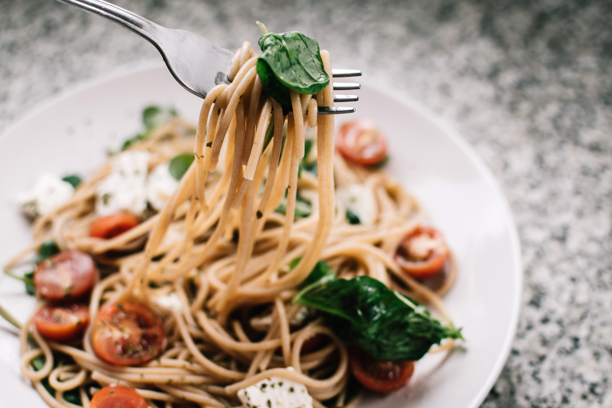

Tomato Basil Pastas
Ingredients
200 grams spaghetti
2 tablespoons olive oil
2 cloves garlic, minced
1 can diced tomatoes
1/2 teaspoon salt
1/2 teaspoon pepper
1/2 cup fresh basil leaves, chopped
1/2 cup grated Parmesan cheese
Directions
- Cook spaghetti according to package instructions. Drain, reserving 1 cup of the pasta water.
- In a skillet, heat olive oil. Sauté garlic until fragrant, then add tomatoes, salt, and pepper. Cook until sauce thickens.
- Add the cooked spaghetti to the skillet, tossing to combine, and adding reserved pasta water if needed.
- Off the heat, garnish with basil and Parmesan. Serve immediately.
Add a pinch of red pepper flakes for a kick.
You can substitute spaghetti with any pasta of your choice.
Tips:
SERVINGS: 2
PREPPING TIME: 15 MIN
COOKING TIME: 30 MIN

